**Introduction**

As part of my FETAC Level 5 Spreadsheet Methods module, I was was required to setup a spreadhseet for a retail outlet that sells electronics. I have designed my spreadsheet for Vision Electronics. The spreadsheet will track wages and sales for 12 employees, some of whom work on a part time basis. This spreadsheet will include the hourly rate, hours worked, sales and bonuses (which will be given for employees who sell 18 or more products (€22 bonus) and employees who sell below 18, with the cut off starting at 10 products (for a €10 bonus). Deductions will include 20% tax.

**Overview of Company details and aims**

Vision Electronics is located on the middle floor of Stephen's Green Shopping Centre. The company has been up and running since March of 2012. Vision Electronics currently employees 12 people, some of which work part time (and the occasional drop in worker). Each employees store ID shows their name, as well as a working code labelled “A” (Full Time), “B” (Part Time) and “C” (Drop In), hours worked in the week and their overall sales of electronics for the week. Full Time workers are on higher rates of pay than Part Time and Drop In workers. Part Time workers currently have the lowest rate of pay. Drop In workers are required to work more hours than part time workers and less than full time workers in order to be paid. The owner of Vision Electronics has asked for me to design a spreadsheet for the store, which is simple to use and will also be easy to show the amount of sales an employee has made, as well as their wages.

The spreadsheet will aim to;

* Show the hourly rate for each employee
* Show the number of sales made by the employees
* Show the deductions from each of the employees’ wages
* Show which employee gets a bonus and which employees do not
* Calculate the net income for each employee

**List of Specific Problems and Solutions**

Problem: A problem I ran into when designing the spreadsheet was the added workers known as “Drop Ins”.

Solution: It was decided that the Drop In workers would need to work more hours than a part time worker and less than a full time worker in order to receive full payment. This was done using an IF function, showing that if the Drop In worker worked more than 10 hours and less than 20, they would be labelled with “C” in their status and given full payment.

Problem: Another problem I ran into was that if Drop In workers didn’t meet the required hours worked, they would still get paid regardless.

Solution: If Drop In workers worked less than their hours required, they would be classed as Part Time workers instead, and receive part time payment.

**Input data**

Input data is information in the spreadsheet that does not need a formula to be worked out, the information is known.

|  |  |  |  |  |  |
| --- | --- | --- | --- | --- | --- |
| **Cell Name** | **Data Type** | **Width** | **Format** | **Protection** | **Cell Reference** |
| Employee Name | Text | 19.86 | Left aligned | No | A8-A20 |
| Sales | Number | 8.43 | Right aligned | No | B8-B20 |
| Hours | Number | 8.43 | Right aligned | No | C8-C20 |
| Rate | Currency | 8.43 | Right aligned | No | B25-D25 |
| Tax Rate | Percentage | 19.86 | Right aligned | No | A28 |

**Output** **data**

Output data is information that changes. The user needs to use formulas to calculate the information.

|  |  |  |  |  |  |
| --- | --- | --- | --- | --- | --- |
| **Cell Name** | **Data Type** | **Width** | **Format** | **Protection** | **Cell Reference** |
| Status | Text | 10.57 | Left aligned | Yes | D8-D20 |
| Hourly Rate | Currency | 10.57 | Right aligned | Yes | E8-E20 |
| Basic Pay | Currency | 11.14 | Right aligned | Yes | F8-F20 |
| Commission | Currency | 11.14 | Right aligned | Yes | G8-G20 |
| Total Payment | Currency | 13.14 | Right aligned | Yes | H8-H20 |
| Deducted Tax | Currency | 13.14 | Right aligned | Yes | I8-I20 |
| Net Income | Currency | 10.57 | Right aligned | Yes | J8-J20 |
| Code | Text | 8.43 | Left aligned | Yes | A24-D24 |

**Data Processing**

The following is a description of the formulas I used in the spreadsheet to calculate the output data.

Hourly Rate: Is got using a lookup function in Cells E9-E20 to find corresponding code and that codes rate of pay in the table in Cells B24-D25. Absolute cell function is used so that the code doesn’t change.   
e.g: =LOOKUP(D9,$B$24:$D$24,$B$25:$D$25)  
  
Basic Pay: Is calculated by multiplying the hours worked in cell C9-C20 by the hourly rate in cell E9-E20. e.g: =C9*E9  
  
Commission: Is got using an IF function in cells G9-G20. If sales is equal to or greater than 18 in cells B9-B20, they get a bonus of €22. If sales is greater than or equal to 10 in cells B9-B20, they get a bonus of €10, otherwise they get nothing. e.g: =IF(B9>=18,22,IF(B9>=10,10,0))  
  
Total Payment: Is calculated by adding basic pay in cell F9-F20 and commission in cell G9-G20. e.g: =SUM(F9+G9)  
  
Deducted Tax: Is calculated by multiplying the total payment in cells H9-H20 by 20% in cell A28. An absolute cell function is used for the tax rate table so that it doesn’t change (but user can change the tax as they see fit). e.g: =H9*$A$28

Net income: Is calculated by taking away tax deductions in cell I9-I20 from the total payment before tax in cell H9-H20. e.g: =SUM(H9-I9)

The header for the spreadsheet project is Verdana font and font size 12.  
  
   
  
  
  
The company name is underlined, in bold, font size 24 and font Bauhaus 93. It is merged and centred.  
  
  
In the Spreadsheet, the input data is shown in a lighter colour and the output data is shown in a darker colour.   
  
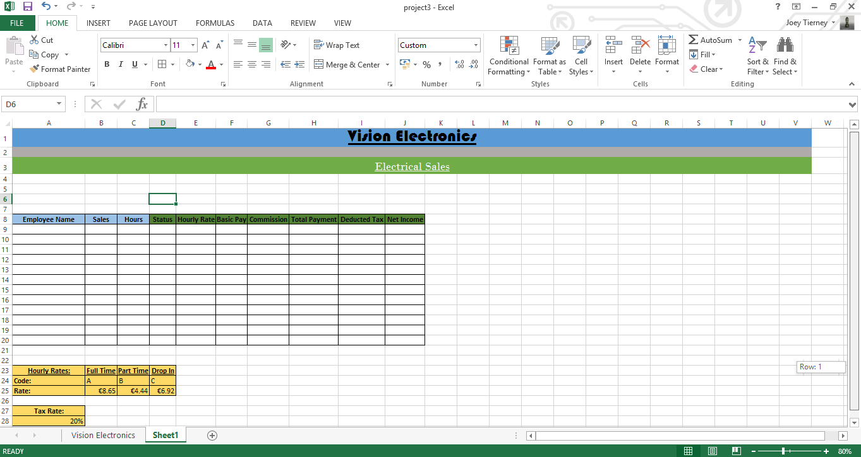  
  
  
The main text is written in Calibri, font size 11, with some headings in bold, while the Hourly Rate table is in bold and underlined. The headings are all centred.  
  
  
This style of layout was chosen as the headings for each cell are clear to see, and the data that the user needs to input is easily visible as well. The Hourly Rate table is highlighted in a different colour to signify that it’s needed for the lookup used in this spreadsheet.

Original Spreadsheet:   
  
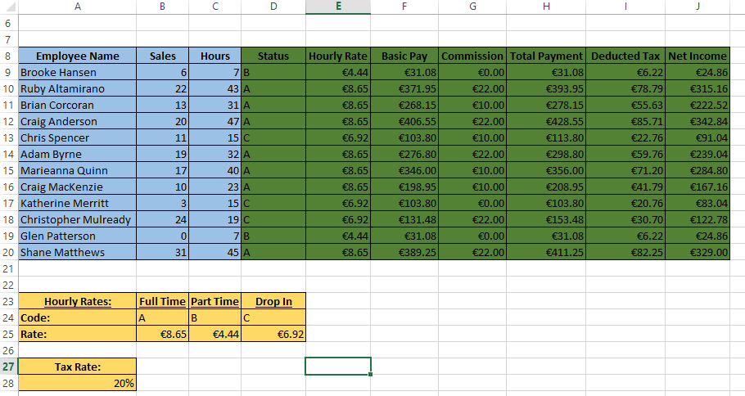  
  
  
After data is changed:  
  
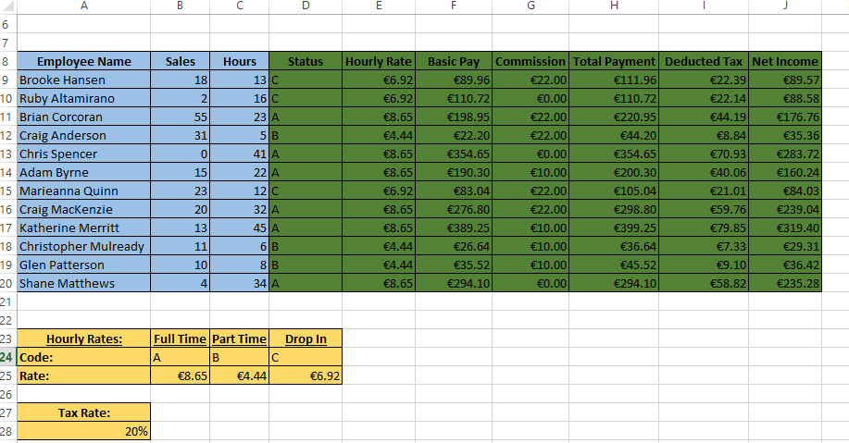

**Evaluation**

Overall, I am satisfied with the outcome of my spreadsheet project.

At the beginning of the spreadsheet project, one of the problems I had was figuring out the best system for the Drop In workers. Deciding how much Drop In workers get paid was difficult, whether to pay them more, less or the same as part time workers, and full time works factored the outcome of the spreadsheet. In the end, I decided that paying Drop In workers €2 more than part time and €2 less than full time workers, as well as including the condition that they need to work more hours than part time works, and less than a full time worker in order to receive their payment.

Another problem was deciding whether or not to calculate the weekly, or monthly wages for each employee. I decided to calculate the employee’s weekly wages, as it worked out well.

A modification that I would make to the spreadsheet would be adding the ability to not give any payments to a Drop In worker who didn’t meet the specifications required to be paid.